**TAZAUNGDAING FESTIVAL**

The Tazaungdaing Lights Festival is a (roughly) yearly event typically happening in October or November leading up to the full moon in the month of Tazaungmon on the lunar calendar. It helps celebrate the end of the rainy season as the transition to the cooler and drier winter will follow. **Oh, and there are fireworks, explosions, and human-powered ferris wheels too.**

My earliest experience with this celebration was the related Yi Peng festival in Northern Thailand, where small white paper lanterns are lit from below and let float gracefully into the air. I remember that experience with awe, watching the orange glow of hundreds of these slowly take off from all around. Leave it to the people of Myanmar to take it up a notch (or 10).

The Tazaungdaing Lights Festival is at it's largest in the city of Taunggyi nestled in the mountains of Shan State. It's here that the celebrations and competitions for the Fire Balloons last more than a week in a field near the university, just outside the city. Daytime activities include all-day weaving competitions and animal-shaped balloons called "Ayoke" being launched into the sky, but it's the night time festivities that are the most noteworthy.

The Tazaungdaing Lights Festival is at it's largest in the city of Taunggyi nestled in the mountains of Shan State. It's here that the celebrations and competitions for the Fire Balloons last more than a week in a field near the university, just outside the city. Daytime activities include all-day weaving competitions and animal-shaped balloons called "Ayoke" being launched into the sky, but it's the night time festivities that are the most noteworthy.

The festival grounds attract huge crowds, and the grounds are pretty massive... enough to hold tens of thousands of people. In fact, it is the second largest in all of Myanmar, sitting only behind the Water Festival in April that essentially shuts the country down for a week or so. They host all sorts of fun activities besides the fire balloons, including a fair grounds with rides like the human-powered Ferris Wheel, carnival games like "Rolling the Bicycle Tire" (my favorite), and more food options than you can possibly need. You can even get yourself a tattoo (not recommended).

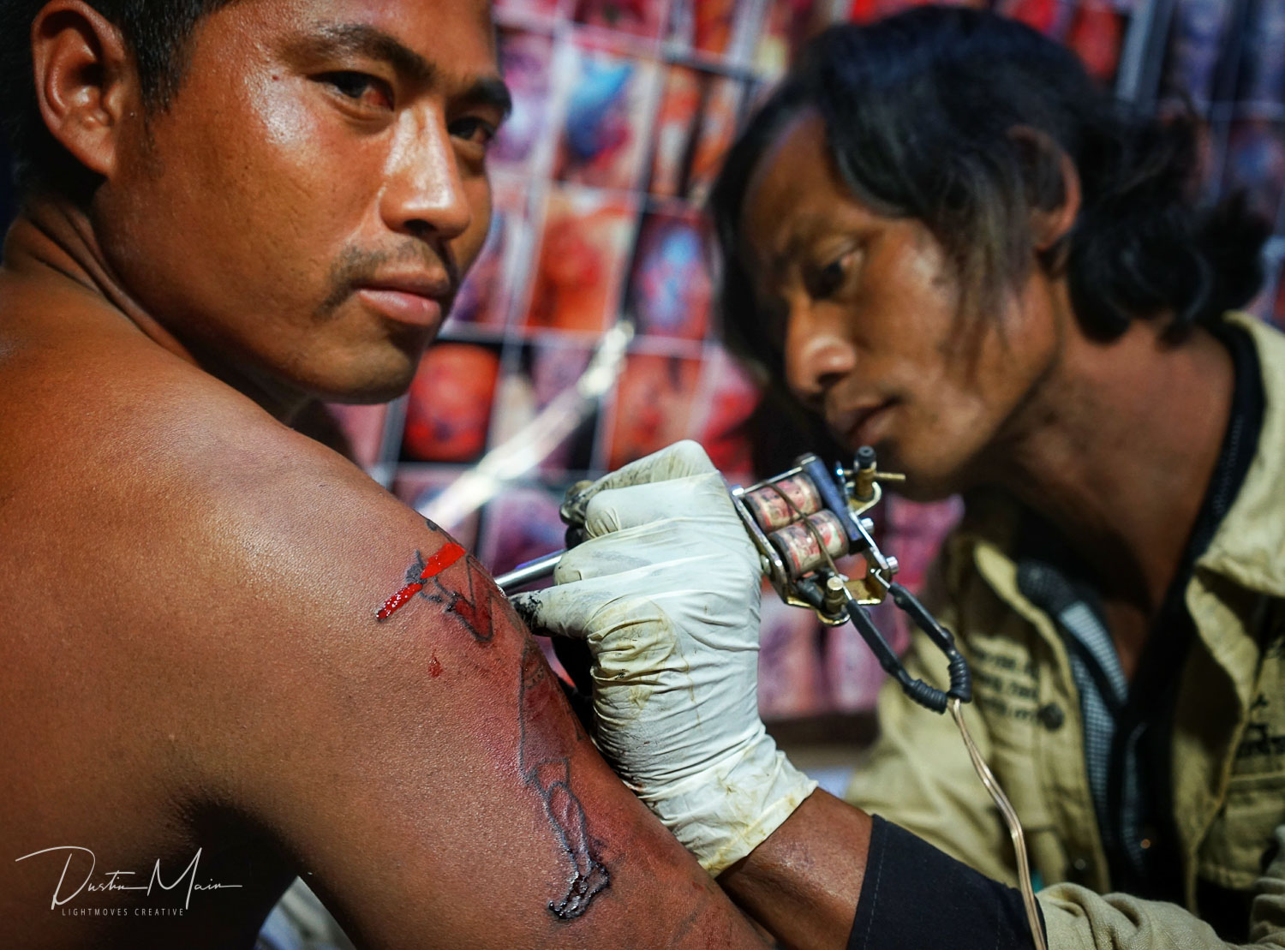

The fire balloons are made of paper, and designed and constructed by the participants themselves. The candles, painting and even the fireworks are all made by hand. It's an expensive affair, often costing thousands and thousands of dollars ($3000-$10000 each), some of which is raised by the community and the rest by sponsorship by corporations.

**Adorned With Lanterns: Sein Na Pan**

There are two types of fire balloons at the festival. The first is adorned in candles called Sein Na Pan, and now is a particularly important time for them. Trays of candles in colored plastic holders are brought out, with little hooks attached to them. As the balloon is inflating from the torches underneath, these folks are finding little colored tabs that have been attached to the balloon and hanging the candles from them. They must work very quickly, because as the balloon inflates and grows taller, these tabs rise higher and quickly become out of reach.

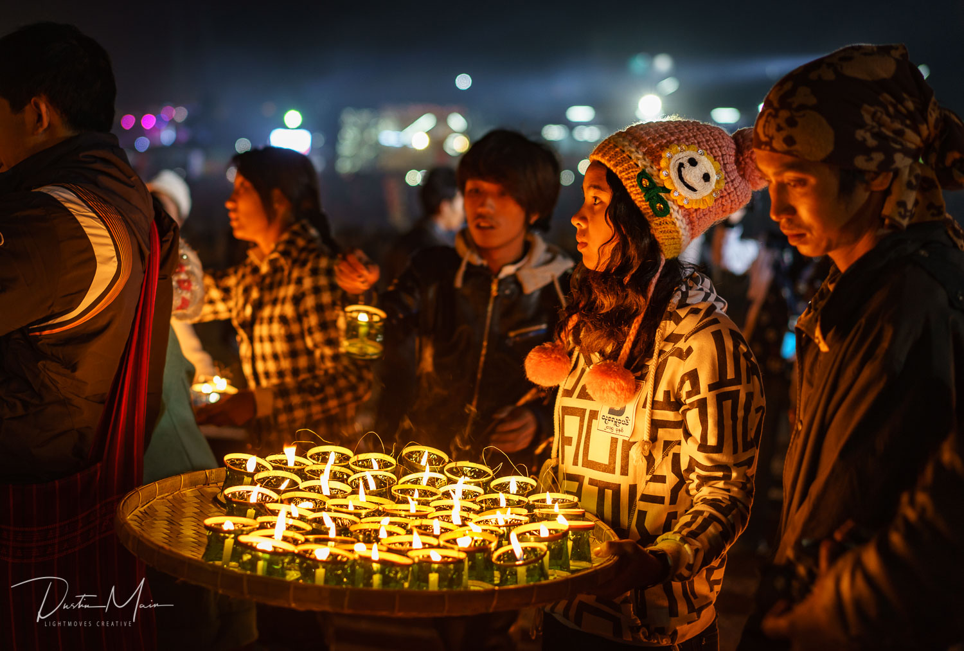

Meanwhile, a whole other group has been working on another part of the display. Off to the side, slim slices of bamboo have been fastened together in a grid approximately 10ft (3m) by 30ft (10m). Hanging from these are little colored plastic loops of which the same colored candle holders as above are attached. Younger folks duck and weave around, lighting each and every candle... and there are hundreds.

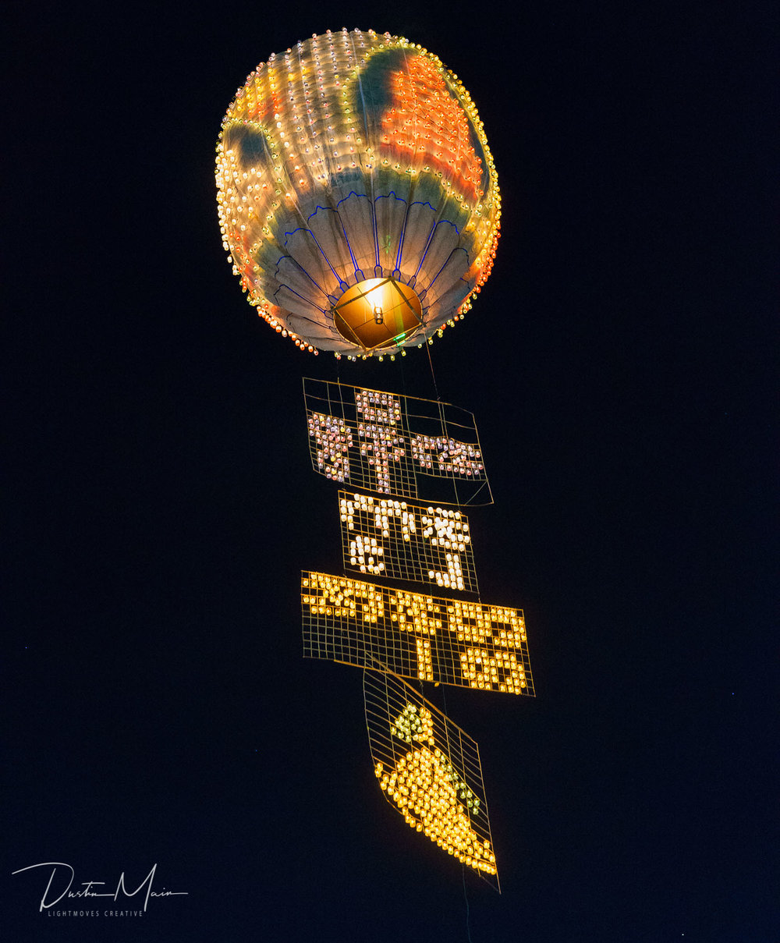

By this time (5-10 minutes later), the balloon is fully inflated. Together, the team members holding the balloon move to rotate the balloon, to show off the design. It's now that you can see the full effect the candles make on the balloon, sometimes as a small picture, Burmese script, or just an interesting design with the painting on the balloon itself as a backdrop.

The torches are now removed from below the balloon, and the "fuel" is attached in their place. This contraption, held together by pieces of rebar, is a solid fuel which makes a flame that will keep the hot air going into the balloon after it leaves the ground, like a giant candle. We're close to liftoff.

If the balloon feels like it has enough lift, the horizontal bamboo grid-of-candles is attached at one end to the bottom of the balloon. If all has gone according to plan, the balloon will be released, and the bamboo will be pulled up along with it, now held vertically. The candles attached to the loops rotate so they don't fall out, and the design of this is now visible as it floats up into the sky.

Now is the time for celebrations, as everyone points up to the balloon, dancing and cheering to the traditional music being played on the drums and cymbals.

**Fire In The Sky: Nya Mee Gyi**

These balloons start off the same way, being brought out and inflated by the fire of fuel-soaked torches. Already though, you see that there is something that sets these apart. The paintings on these fire balloons are typically quite elaborate and no candles are attached to them. The work really pops as the spotlights shine on them.

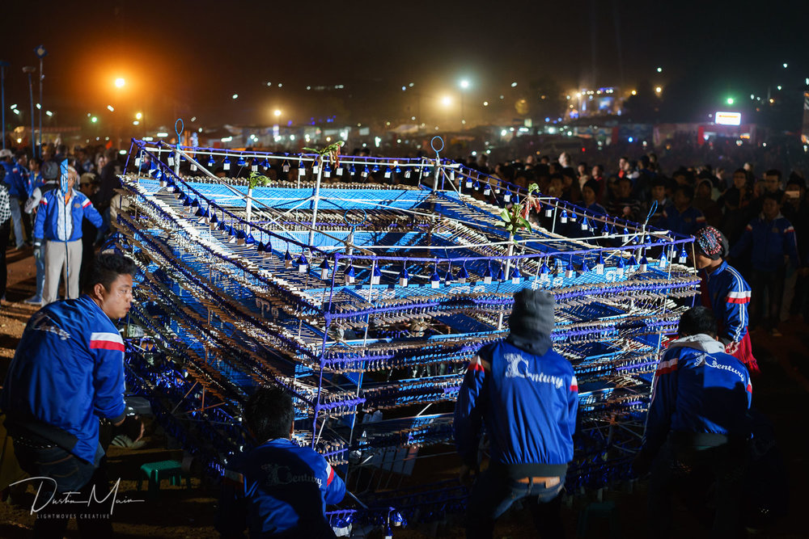

And here comes what I lovingly refer to as "The Payload." A palatte-sized contraption, about 4-5ft (1.5m) tall is brought out and unwrapped. This thing is made of up to 5000 hand-made fireworks, and once the balloon is inflated, they will attach it to the bottom to take it for a ride to the sky.

They need some space below for it, so the inflated fire balloon is attached to a few ropes and released, allowing it to rise while still being tethered down. One person will hold a metal bucket on the end of a long pole from below the fire balloon to catch the dripping wax from the "fuel" so it doesn't land on the fireworks of the payload while it is attached underneath. This is also the time when people start moving away, and fast.

Once the balloon has created enough lift (or at least they think it has), the fuse is lit and the balloon is released. If all goes well, the fire balloon heads up into the sky and after 10-20 seconds, the fuse will reach the fireworks and they begin going off, shooting all around in mid air from the balloon. There is not a straight neck in the festival grounds as everyone has their eyes transfixed on the fireworks display. It is seriously something spectacular, and something that just can't be captured on video in a way that does it any justice. Smiles brought on by awe are everywhere around as the balloon floats higher up, getting smaller in the distance as the fireworks continue to fire for 10-15 minutes.

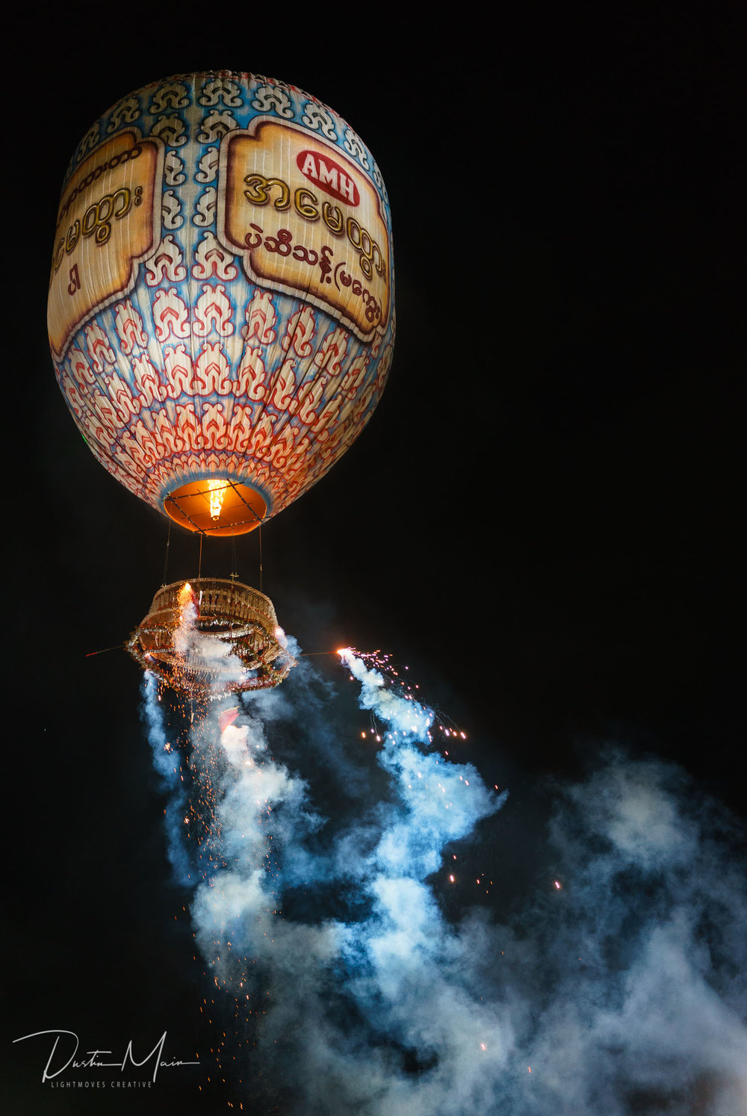

**What You Need To Know If You Go**

If you're going to head to the Fire Balloon Festival in Taunggyi, here are some tips to make it the most enjoyable and safe experience for you.

**When is the Tazaungdaing Fire Balloon Festival in 2020?**

Tazaungdaing 2020 will be celebrated from November 3rd to Nov 12th.

1) Bring a guide, and listen to them.

It is absolutely worth bringing a guide, both to help make sense of all that is happening, and to keep you safe. While your jaw is dropping in awe of what you're experiencing, they will know what to expect and be keeping an eye on the surroundings. They know how the balloons behave, where you should go, and when you need to move away.

2) Stay out of the way.

Chances are, you'll want to be getting a close-up look of the action. That's all well and good, but remember that these people have been preparing for months for this competition, and do not want you getting in their way. Oh yeah, and people are walking around with massive flaming torches. It's really important to be aware of what's happening around you.

3) Wear long pants and clothes made of natural fabrics.

It's often chilly at night up in the mountains around Taunggyi, so dress appropriately. Given that you're potentially in an environment around fire, natural fabrics are best in case a rogue firework comes your way.

4) Be aware of your surroundings.

The festival grounds are busy, most nights with tens of thousands of people attending each night. When you arrive, take a look around to see the lay of the land so you know how to get back to your guide / driver in case you get split up. Know where the fire station crew is as well as the covered viewing area, and don't take anything you can't afford to lose.

5) The weather matters.

It's typically not that windy this time of the year in the evenings, but the slightest breeze will dictate which direction the balloon will float. The breeze may shift often as well, so be aware of the changes.

*Source: dustinmain.com*